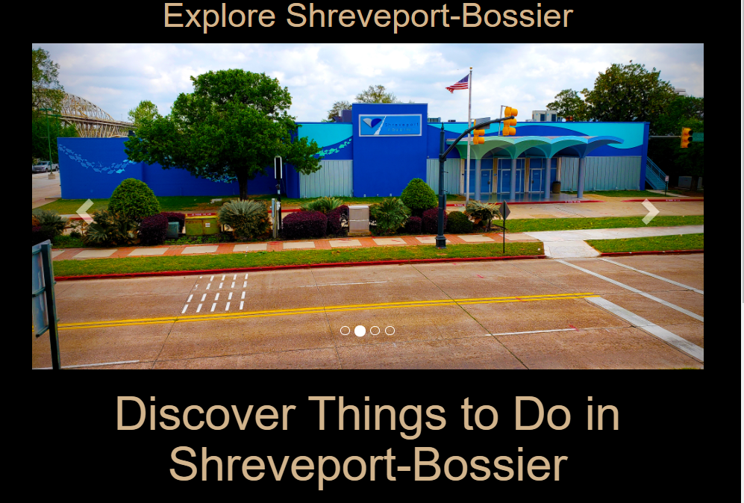

This is the landing page once the User searches for Entertainment.

Carousel of Slides :

<div class="carousel-inner" style="width:100%;">

          <div class="item active">

            <img src="./Images/Entertainment/SOBO.jpg" alt="Los Angeles" >

            </div>

              <div class="item">

                  <img src="./Images/Entertainment/Aquarium.jpg" alt="Los Angeles" >

                </div>

                <div class="item">

                  <img src="./Images/Entertainment/Outdoorfun.jpg" alt="Chicago" >

                </div>

                <div class="item">

                  <img src="./Images/Entertainment/Gardens_at_R_W.jpg" alt="New york" >

                </div>

              </div>

Pictures Used:

./Images/Entertainment/SOBO.jpg

./Images/Entertainment/Aquarium.jpg

./Images/Entertainment/Outdoorfun.jpg

./Images/Entertainment/ Gardens_at_R_W.jpg

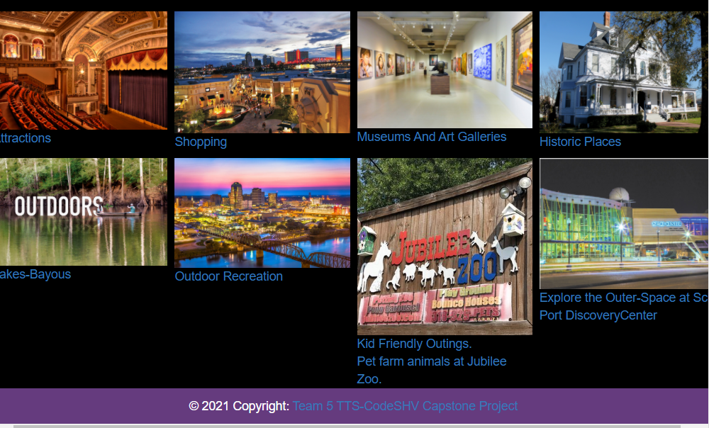

Attractions :

https://thestrandtheatre.com/

<div class= "row">

            <div class="column">

              <a href="https://thestrandtheatre.com/" >

                <img class = "image" src="./Images/Entertainment/Strand-inside.jpg" alt="photo" />

                <div class="caption center">Attractions</div>

                </a>

              </div>

Shopping:

<https://www.louisianaboardwalk.com/>

 <div class="column">

                  <a href="https://www.louisianaboardwalk.com/">

                  <img class = "image" src="./Images/Entertainment/Louisiana-Boardwalk-Outlets.jpg" alt="Card image cap">

                   Shopping

                  </a>

                </div>

Museums And Art Galleries:

<https://www.shreveport-bossier.org/things-to-do/museums-galleries/>

div class="column">

                  <a href="https://www.shreveport-bossier.org/things-to-do/museums-galleries/" >

                <img class = "image" src="./Images/Entertainment/Norton-Museum-of-Art.jpg"  alt="Not displaying museum">

                <div class="caption center">Museums And Art Galleries</div>

                </a>

                  </div>

Historic Places :

<https://www.shreveport-bossier.org/things-to-do/historic-places/>

<div class="column">

                    <a href="https://www.shreveport-bossier.org/things-to-do/historic-places/">

                            <img class = "image" src="./Images/Entertainment/Logan-Mansion.jpg" alt="Card image cap">

                      Historic Places

                      </a>

                    </div>

Lakes-Bayous:

<https://www.shreveport-bossier.org/things-to-do/outdoor-recreation/lakes-bayous-rivers/>

<div class="column">

                        <a href="https://www.shreveport-bossier.org/things-to-do/outdoor-recreation/lakes-bayous-rivers/">

                          <img class = "image" src="./Images/Entertainment/outdoorboating.jpg" alt="Card image cap">

                          Lakes-Bayous

                        </a>

                      </div>

Outdoor Recreation :

<https://vacationidea.com/louisiana/best-things-to-do-in-shreveport.html>

<div class="column">

                        <a href="https://vacationidea.com/louisiana/best-things-to-do-in-shreveport.html">

                        <img class = "image" src="./Images/Entertainment/River-cruise.jpg" alt="Card image cap">

                         Outdoor Recreation

                       </a>

                       </div>

Kid Friendly Outings :

<https://jubileezoo.com/>

 <div class="column">

                       <a href="https://jubileezoo.com/">

                        <img class = "image"  src="./Images/Entertainment/Jubileezooo.jpg" width = 200px height = 200px alt="card image cap">

                      Kid Friendly Outings.

                     <br> Pet farm animals at Jubilee Zoo.

                      </a>

                  </div>

Family Fun :

<https://sci-port.org/>

<div class="column">

                    <a href="https://sci-port.org/"> Family Fun

                      <img class = "image" src="./Images/Entertainment/sciport-1.jpg" alt="Card image cap">

                        Explore the Outer-Space at Sci-Port DiscoveryCenter

                      </a>

                    </div>

Images :

./Images/Entertainment/Strand-inside.jpg

./Images/Entertainment/Louisiana-Boardwalk-Outlets.jpg

./Images/Entertainment/Norton-Museum-of-Art.jpg

./Images/Entertainment/Logan-Mansion.jpg

./Images/Entertainment/outdoorboating.jpg

./Images/Entertainment/Jubileezooo.jpg

./Images/Entertainment/sciport-1.jpg

Footer:

 <footer class="page-footer font-small white">

  <!-- Copyright -->

  <div class="footer-copyright text-center py-5">© 2021 Copyright:

    <a href="https://mdbootstrap.com/"> Team 5 TTS-CodeSHV Capstone Project</a>

  </div>

</footer>

<!-- Footer -->

Navbar:

<nav class="navbar navbar-dark bg-primary">

    <button class="navbar-toggler" type="button" data-toggle="collapse" data-target="#navbarTogglerDemo01" aria-controls="navbarTogglerDemo01" aria-expanded="false" aria-label="Toggle navigation">

        <span class="navbar-toggler-icon"></span>

    </button>

    <div class="collapse navbar-collapse" id="navbarTogglerDemo01">

        <a class="navbar-brand" href="#">Hidden brand</a>

        <ul class="navbar-nav mr-auto mt-2 mt-lg-0">

            <li class="nav-item active">

                <a class="nav-link" href="#">Home <span class="sr-only">(current)</span></a>

            </li>

            <li class="nav-item">

                <a class="nav-link" href="#">Link</a>

            </li>

            <li class="nav-item">

                <a class="nav-link disabled" href="#">Disabled</a>

            </li>

        </ul>

        <form class="form-inline my-2 my-lg-0">

            <input class="form-control mr-sm-2" type="search" placeholder="Search" aria-label="Search">

            <button class="btn btn-outline-success my-2 my-sm-0" type="submit">Search</button>

        </form>

    </div>

</nav>

**Festivals:**

This is one of the tabs in the SmartCity Searches .This page loads the festivals and Events in Shreveport-Bossier.

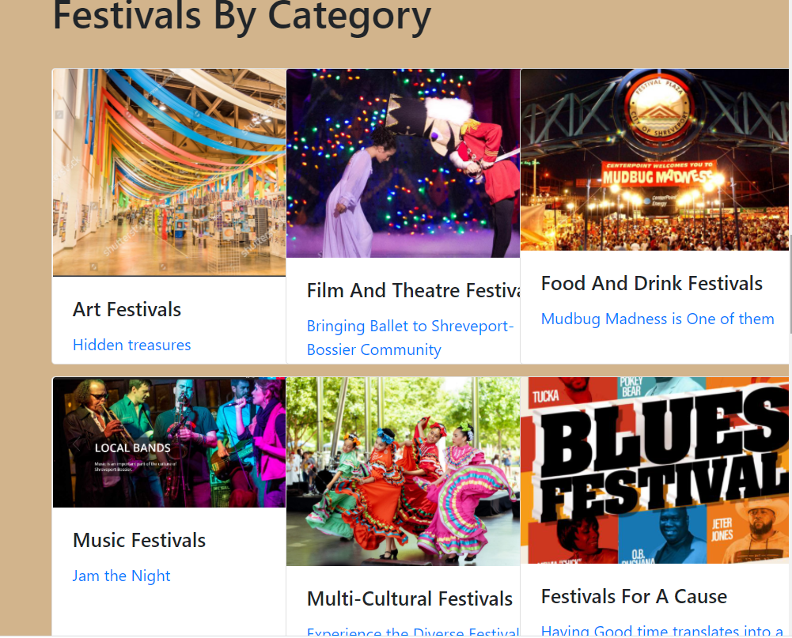

Carousel Slide Images :

<div id="carouselExampleControls"

          class="carousel slide" data-ride="carousel">

        <div class="carousel-inner">

        <div class="carousel-item active">

        <img src="./Images/Festivals & Events/Music Festival.png"

         class="d-block w-100" alt="food">

        </div>

         <div class="carousel-item">

         <img src="./Images/Festivals & Events/Shreveport_Mardigras_home.jpg"

         class="d-block w-100" alt="food">

         </div>

           <div class="carousel-item">

            <img src="./Images/Festivals & Events/Red River Revel.jpg"

                class="d-block w-100" alt="food">

             </div>

            </div>

**Images Used in the Carousel :**

./Images/Festivals & Events/Music Festival.png

./Images/Festivals & Events/Shreveport_Mardigras_home.jpg

./Images/Festivals & Events/Red River Revel.jpg

Festivals By Category :

<div class="card-columns">

        <div class="card" style="width: 18rem;">

          <img class="card-img-top" src="./Images/Festivals & Events/Art Festivals/Art-Festivals.jpg" alt="Art Festivals">

        <div class="card-body">

          <h5 class="card-title">Art Festivals</h5>

          <a href="https://www.shrevearts.org/">Hidden treasures</a>

        </div>

        </div>

            <div class="card" style="width: 18rem;">

        <img class="card-img-top" src="./Images/Festivals & Events/Music Festivals/Music Festival.png" alt="Cafe">

         <div class="card-body">

        <h5 class="card-title">Music Festivals</h5>

        <!-- rd<p class="card-text">Italian</p> -->

        <a href="https://www.sbfunguide.com/events/concerts/">Jam the Night</a>

      </div>

      </div>

       <div class="card" style="width: 18rem;">

    <img class="card-img-top" src="./Images/Festivals & Events/Film & Theatre Festivals/btn-snow-white.jpg" alt="El">

    <div class="card-body">

      <h5 class="card-title">Film And Theatre Festivals</h5>

      <a href="https://www.shreveportmetroballet.org/" >Bringing Ballet to Shreveport-Bossier Community</a>

    </div>

    </div>

       <div class="card" style="width: 18rem;">

    <img class="card-img-top" src="./Images/Festivals & Events/MultiCultural Festivals/MC.jpg" alt="El">

    <div class="card-body">

      <h5 class="card-title">Multi-Cultural Festivals</h5>

      <a href="https://www.shreveport-bossier.org/listing/aseana-festival/1718/">Experience the Diverse Festivals that Shreveport has to Offer</a>

    </div>

    </div>

       <div class="card" style="width: 18rem;">

    <img class="card-img-top" src="./Images/Festivals & Events/Food And Drink Festivals/MudbugMadness_web.jpg" alt="El">

    <div class="card-body">

      <h5 class="card-title">Food And Drink Festivals</h5>

      <a href="https://mudbugmadness.com/">Mudbug Madness is One of them</a>

    </div>

    </div>

       <div class="card" style="width: 18rem;">

    <img class="card-img-top" src="./Images/Festivals & Events/Festivals for a good cause/GoodCause.jpg" alt="El">

    <div class="card-body">

      <h5 class="card-title">Festivals For A Cause</h5>

      <a href="https://www.shreveportmunicipalauditorium.com/events/">Having Good time translates into a good cause</a>

    </div>

    </div>

  </div>

    </section>

Images Used in this Category :

./Images/Festivals & Events/Art Festivals/Art-Festivals.jpg

./Images/Festivals & Events/Music Festivals/Music Festival.png

./Images/Festivals & Events/Film & Theatre Festivals/btn-snow-white.jpg

./Images/Festivals & Events/MultiCultural Festivals/MC.jpg

./Images/Festivals & Events/Food And Drink Festivals/MudbugMadness_web.jpg

./Images/Festivals & Events/Festivals for a good cause/GoodCause.jpg

Festivals By Seasons :

<section>

            <div class="container">

            <h1>

                Festivals By Seasons

            </h1>

            <br>

      <div class="card-columns">

          <div class="card" style="width: 15rem; ">

      <img class="card-img-top" src="./Images/Festivals & Events/Festivals By Seasons/Spring.jpg" alt="Spring Festivals">

        <div class="card-body">

         <h5 class="card-title">Spring Festivals</h5>

        <a href="https://www.shrevearts.org/">Spring is in the Air!</a>

        </div>

        </div>

             <div class="card" style="width: 15rem;">

          <img class="card-img-top" src="./Images/Festivals & Events/Festivals By Seasons/summer.png" alt="Summer Festivals">

        <div class="card-body">

       <h5 class="card-title">Summer Festivals</h5>

        <a href="https://www.louisianatravel.com/events/summer">EveryOne Can Beat the Heat This Summer<a>

       </div>

         </div>

            <div class="card" style="width: 15rem;">

          <img class="card-img-top" src="./Images/Festivals & Events/Festivals By Seasons/Fall.jpg" alt="Fall Festivals">

      <div class="card-body">

          <h5 class="card-title">Fall Festivals</h5>

        <a href="https://www.shreveport-bossier.org/fall/">Fall Into Fun</a>

       </div>

        </div>

            <div class="card" style="width: 15rem;">

        <img class="card-img-top" src="./Images/Festivals & Events/Festivals By Seasons/Winter.jpg" alt="Winter">

         <div class="card-body">

       <h5 class="card-title">Winter Festivals</h5>

            <a href="https://www.holidaytrailoflights.com/"> Believe in the Magic Of Christmas Cheer This Winter Holidays!

           </a>

       </div>

         </div>

      </div>

    </section>

Images Used in this Section are:

./Images/Festivals & Events/Festivals By Seasons/Spring.jpg

./Images/Festivals & Events/Festivals By Seasons/summer.png

./Images/Festivals & Events/Festivals By Seasons/Fall.jpg

./Images/Festivals & Events/Festivals By Seasons/Winter.jpg

Festivals Sure You’ll Not want to Miss :

<section>

            <div class="container">

            <h1>

                Festivals Sure y'All Not Want to Miss!

            </h1>

            <br>

            <div class="card-columns">

          <div class="card" style="width: 15rem; ">

      <img class="card-img-top" src="./Images/Festivals & Events/FestivalsNotToMiss/MardiGrasBash_03.jpg" alt="Spring Festivals">

        <div class="card-body">

         <h5 class="card-title">Experience Mardi-Gras</h5>

        <a href="https://www.sbfunguide.com/events/mardi-gras/">A Partier's Guide to MardiGras</a>

        </div>

        </div>

          <div class="card" style="width: 15rem; ">

      <img class="card-img-top" src="./Images/Festivals & Events/FestivalsNotToMiss/Heritage.jpg" alt="Spring Festivals">

        <div class="card-body">

         <h5 class="card-title">Ark-La-Tx Heritage Festival</h5>

        <a href="https://www.everfest.com/e/ark-la-tex-music-heritage-festival-shreveport-la">Keeping Live Music Alive</a>

        </div>

        </div>

             <div class="card" style="width: 15rem;">

          <img class="card-img-top" src="./Images/Festivals & Events/FestivalsNotToMiss/SBCTB-Red-River-Balloon-Rally.jpg" alt="Summer">

        <div class="card-body">

       <h5 class="card-title">Red-River-Balloon Rally</h5>

        <a href="https://redriverballoonrally.com/" >Magical Experience For All Ages</a>

       </div>

         </div>

            <div class="card" style="width: 15rem;">

          <img class="card-img-top" src="./Images/Festivals & Events/FestivalsNotToMiss/780x400-lantern-festival.jpg" alt="Fall">

      <div class="card-body">

          <h5 class="card-title"> Water Lantern Festival</h5>

        <a href="https://www.waterlanternfestival.com/shreveport.php">Light the Water</a>

       </div>

        </div>

    </section>

**Images Used in this Section Are:**

./Images/Festivals & Events/FestivalsNotToMiss/MardiGrasBash_03.jpg

./Images/Festivals & Events/FestivalsNotToMiss/Heritage.jpg

./Images/Festivals & Events/FestivalsNotToMiss/SBCTB-Red-River-Balloon-Rally.jpg

./Images/Festivals & Events/FestivalsNotToMiss/780x400-lantern-festival.jpg

Footer :

     <!-- Footer -->

       <footer class="page-footer font-small white">

    <!-- Copyright -->

      <div class="footer-copyright text-center py-5">© 2021 Copyright:

      <a href="https://mdbootstrap.com/"> Team 5 TTS-CodeSHV Capstone Project</a>

    </div>

  </footer>

  <!-- Footer -->

</html>